User guide of RAPID RESCUE



**INFORMATION REGARDING AMBULANCE:**

The main purpose of an ambulance is to provide immediate emergency medical care and transportation to individuals experiencing serious or life-threatening conditions. Equipped with essential medical equipment and staffed by trained professionals, such as paramedics and EMTs, ambulances deliver crucial care while route to healthcare facilities. They facilitate rapid response, navigating through traffic and accessing challenging locations using sirens and lights to alert other drivers. In addition to providing advanced life support and stabilizing patients during transport, ambulances maintain communication with hospitals to prepare medical staff for incoming cases. Furthermore, they often play a vital role in community services, offering public health education and non-emergency medical transport. During disasters, ambulances are critical for on-site medical care in mass casualty incidents. Overall, ambulances are integral to the healthcare system, ensuring timely access to vital medical services and contributing significantly to saving lives and improving patient outcomes.

**Purpose of ambulance:**

The purpose of ambulances in hospitals encompasses several key functions:

1. **Patient Transport**: Ambulances are essential for transporting patients from accident sites, homes, or other medical facilities to hospitals, ensuring they receive urgent care when needed.
2. **Emergency Response**: They provide rapid response to emergencies, allowing healthcare professionals to begin medical care on-site and continue treatment during transport.
3. **Inter-Facility Transfers**: Ambulances facilitate the transfer of patients between different hospitals, especially when specialized care or resources are required that one facility cannot provide.
4. **Stabilization**: While transporting patients, ambulances allow for monitoring and stabilization of vital signs, administering medications, and performing life-saving procedures to prevent deterioration.
5. **Communication with Hospitals**: Ambulances maintain communication with hospital staff, providing updates on patient conditions and ensuring that appropriate resources are ready upon arrival.
6. **Disaster and Emergency Preparedness**: Hospitals utilize ambulances as part of their emergency response plans, ensuring readiness for mass casualty incidents and other disasters.

**Role of ambulance in life link:**

Ambulances provide a range of essential benefits that are crucial for effective emergency medical services and public health. They enable rapid response to emergencies, significantly reducing the time it takes to transport patients to medical care. Equipped with advanced medical equipment and staffed by trained paramedics and EMTs, ambulances offer immediate medical care on-site, helping to stabilize patients before they reach the hospital. Their design ensures safe transportation, minimizing movement and discomfort while providing ongoing medical supervision. Furthermore, ambulances can access hard-to-reach locations, ensuring timely assistance even in remote areas. They facilitate coordination with healthcare facilities by communicating patient conditions in advance, allowing hospitals to prepare for incoming cases. Additionally, ambulance services often engage in community outreach to educate the public on health and safety. They also support non-emergency medical transport for patients needing assistance with routine appointments. In disaster situations, ambulances play a vital role in providing immediate care and transporting multiple patients. Overall, ambulances are a critical component of the healthcare system, enhancing access to care and improving patient outcomes during emergencies.

**Home page:**

In Home page user have to register and login before going to website Then after some graphic user can be aware about our latest services and Our latest articles & blogs for their benefits.

**Services:**

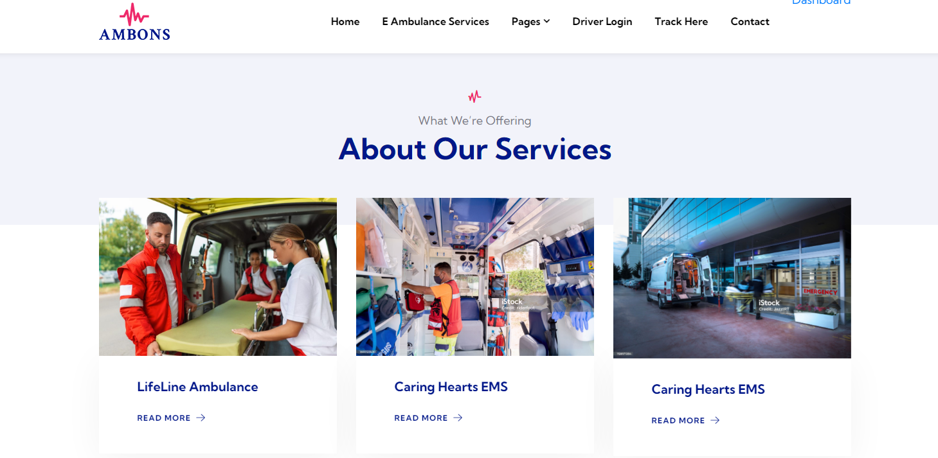

**Blogs:**

from this part user can be acknowledge about the latest blogs and articles for their more information.

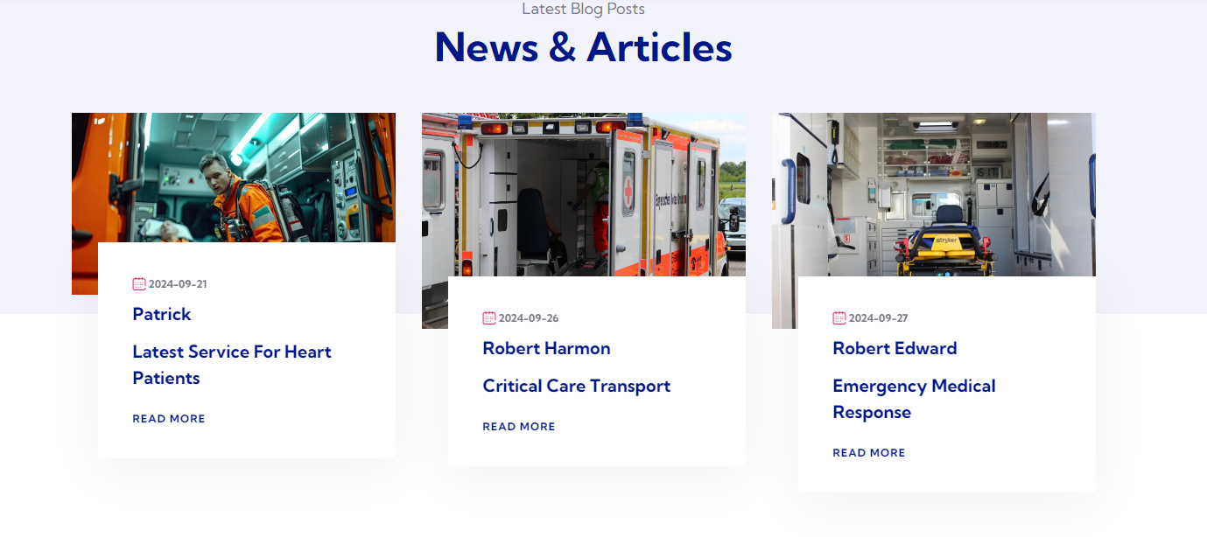

**About Page:**

In this about page user can easily as we have mentioned the information and bio regarding our medical and ambulance staff who are not only reliable also professional when it comes to their job and their work.

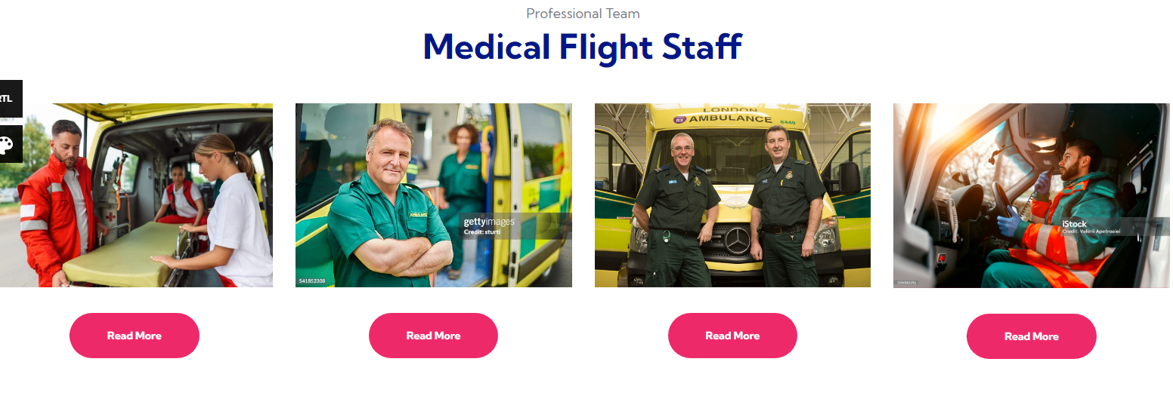

From this part user can be acknowledge of our service percentage

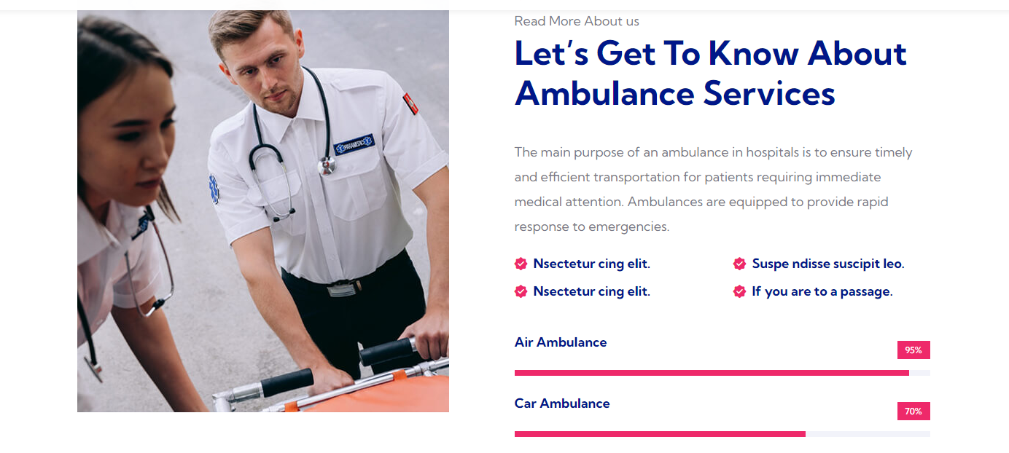

**E-Ambulance Service Page:**

In this page user can easily be aware about the description related to our services which we are providing to patients through ambulance.

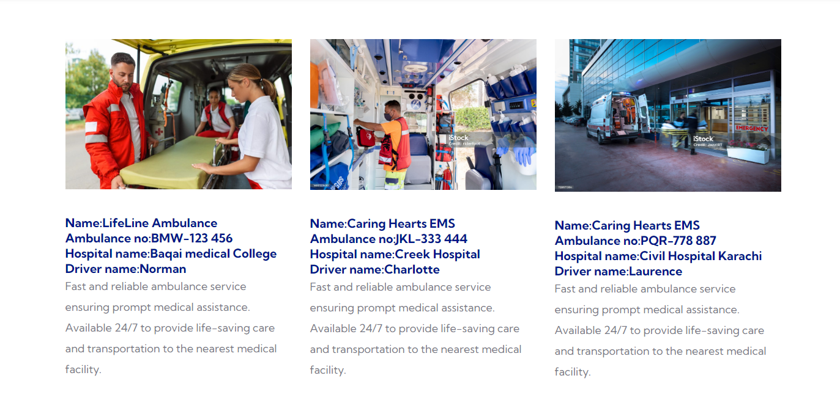

**Team Page:**

In this part of website user can easily get the info about our team members who are always ready to show their generosity and ready to help other

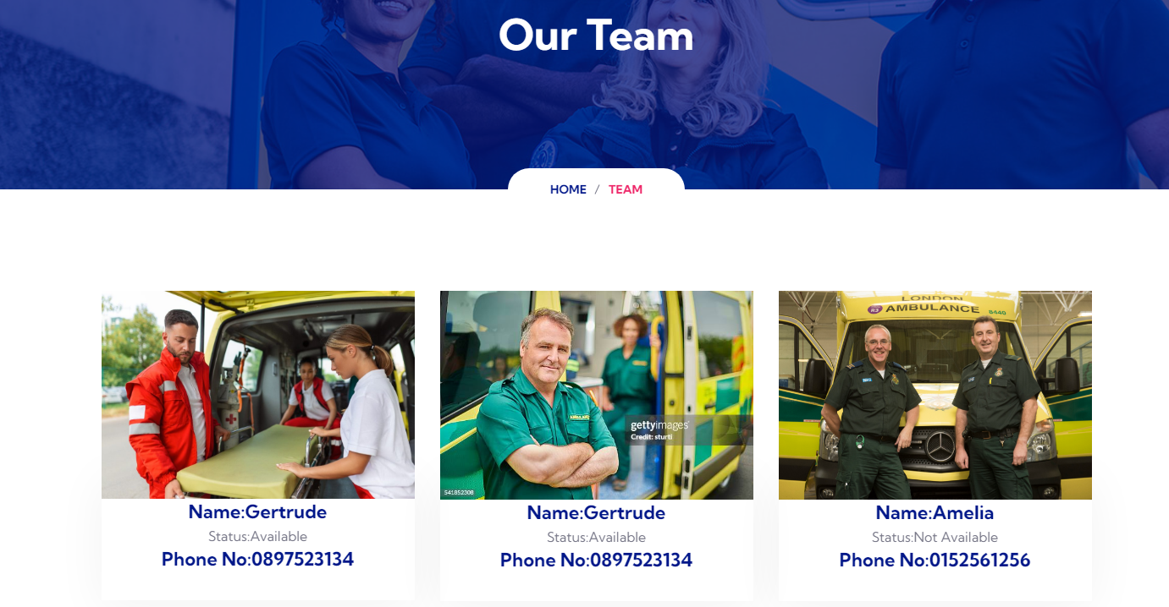

**Drivers Page:**

From this page user can be easily get aware about the drivers and are able to chose the drivers of their own also they first have to login by putting their email address and password.

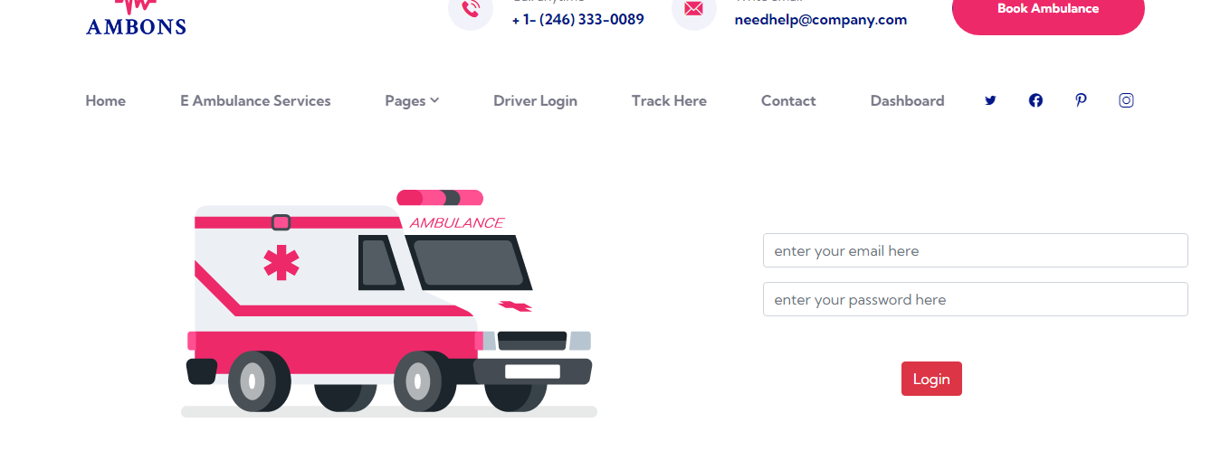

**Testimonials Page:**

From this page user can easily see the feedback they submitted after get a chance to receive our service and as a proof of their satisfaction

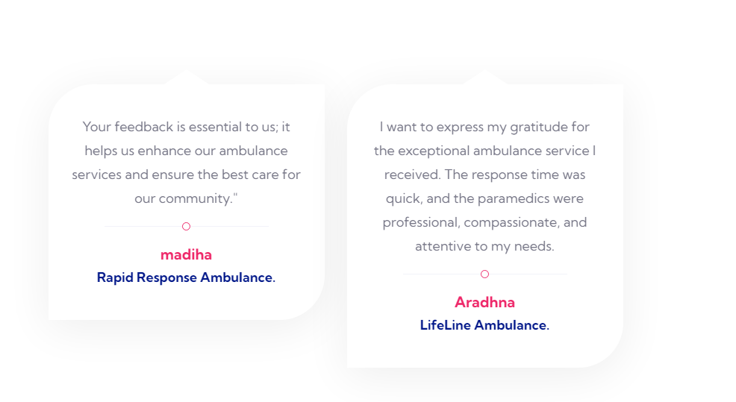

**Book Ambulance:**

From this button user can easily get an access of the page where they can book the ambulance according to their own reliability after filling up the information they require to.



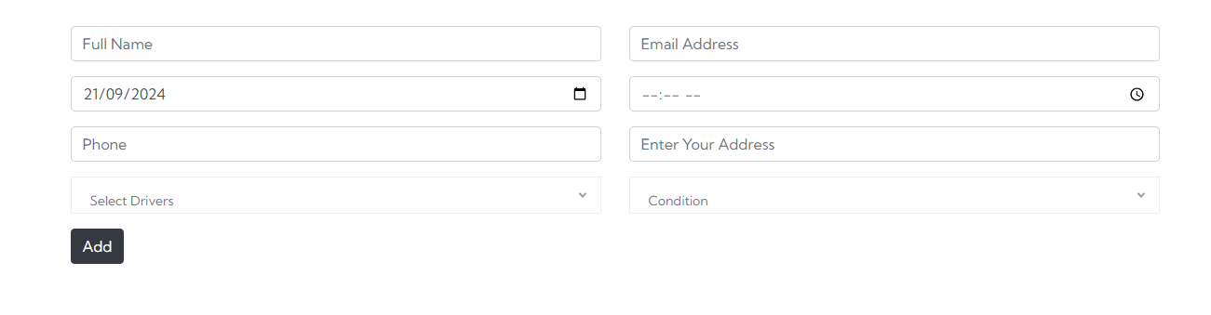

**Tracking Page:**

From this page user can easily pull up the information regarding their booking by putting their tracking id which they’ll get after booking the ambulance of their own choice.

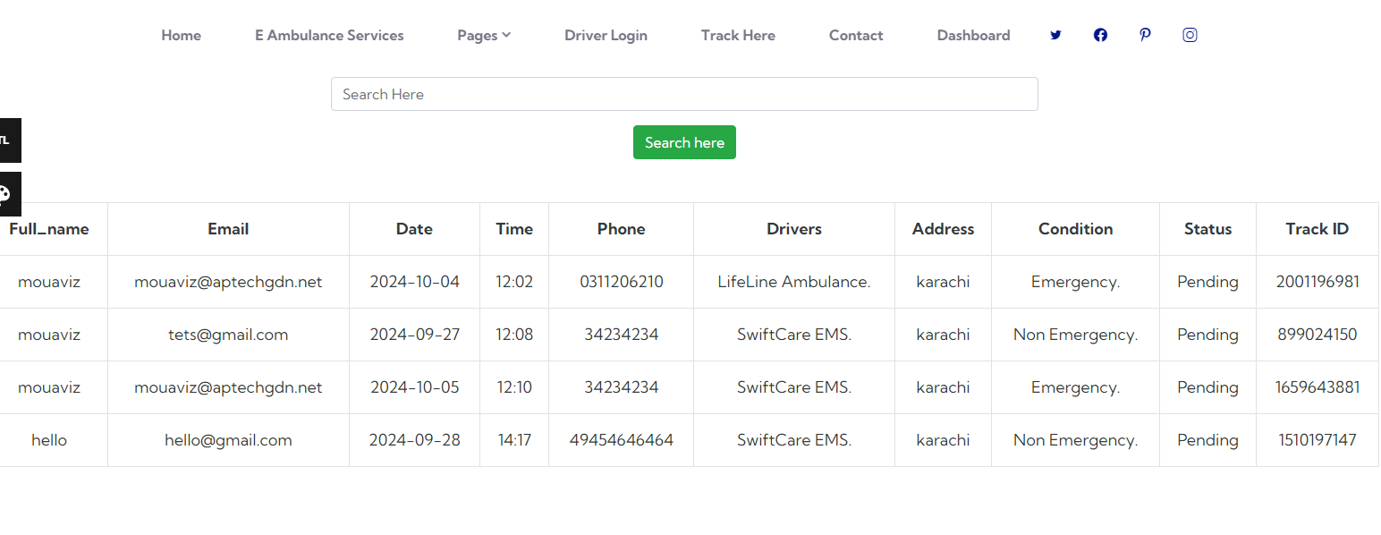

**Contact Page:**

In this page user have to leave the message by putting their some information in the given form so that an admin can see all contacts of our website users

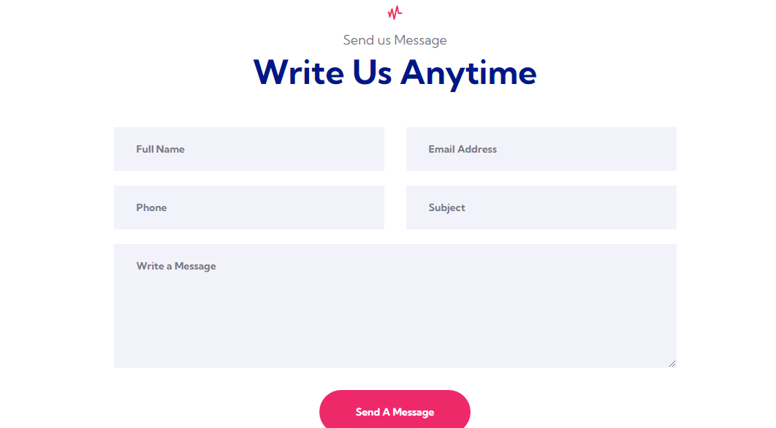

Dashboard

**Admin dashboard:**

**Driver record:** here admin can insert new drivers also can see all records of our available driver

**Feedback record**: here admin can see all the feedback received by users

**Contact record:** here admin can see all contacts and and are able to delete as well

**User data:** here admin are able to see users data also are able to delete and edit the role to go to any other dashboard like user and driver.

**Booking record**: here admin can see their latest booking by users

Search ambulance: admin can search the data by names also can directly go to user dashboard

**Add blog**: here admin can add blog and articles also can view it

**User Dashboard:**

**Insert feedback:** here user can easily fill the feedback by giving us a survey also can view their own feedbacks

**Contact record:** user can easily see their own contact information

**Search ambulance:** user can easily search their ambulance by searching their names

**Driver Dashboard:**

**Feedback:** driver can see feedback given from users on their services

**Contact** : driver can see all contacts

**ADMIN DASHBOARD**

Drivers insert

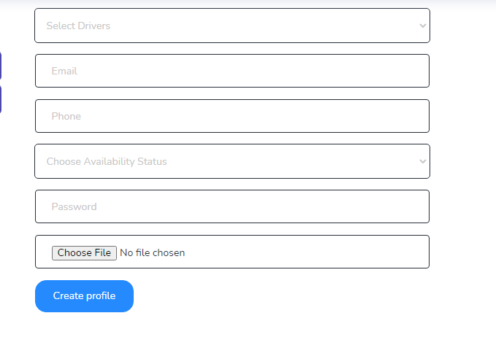

Show driver record

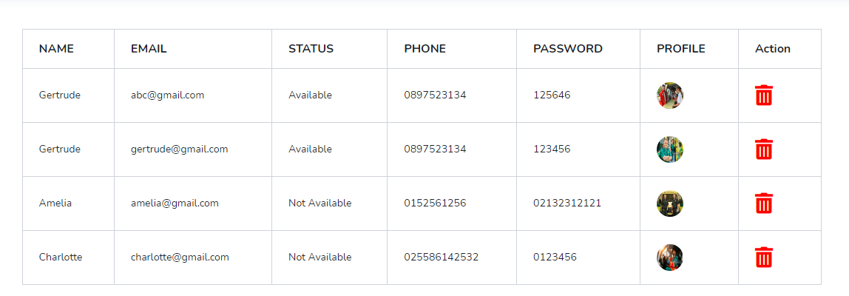

Show feedback:

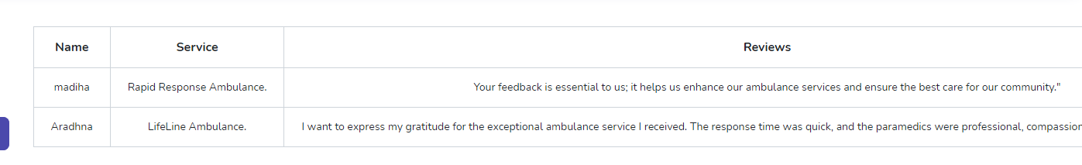

Contact record

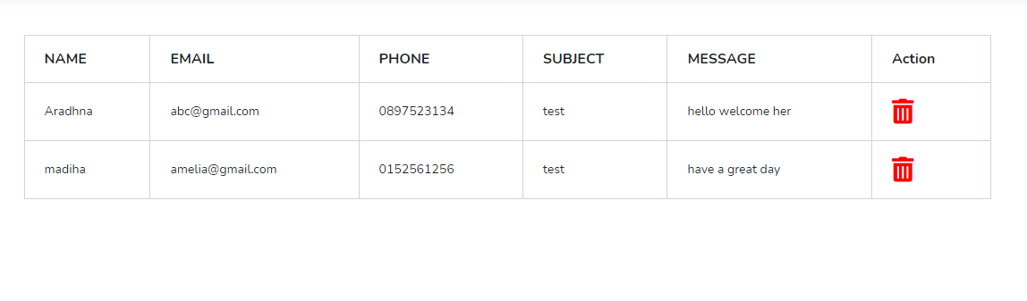

User record:

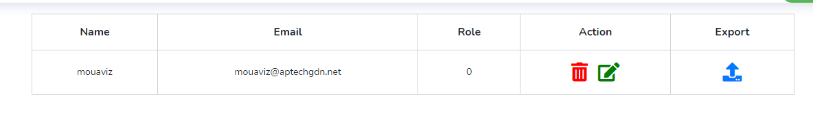

Booking record:

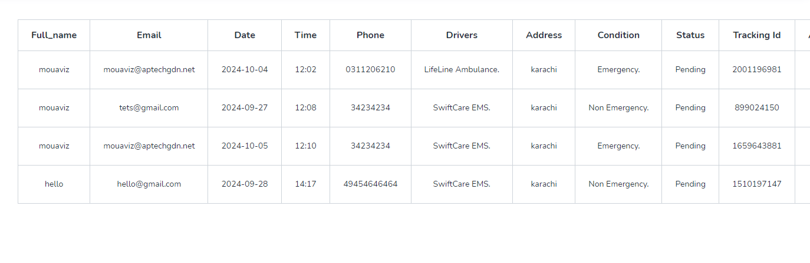

Search ambulance

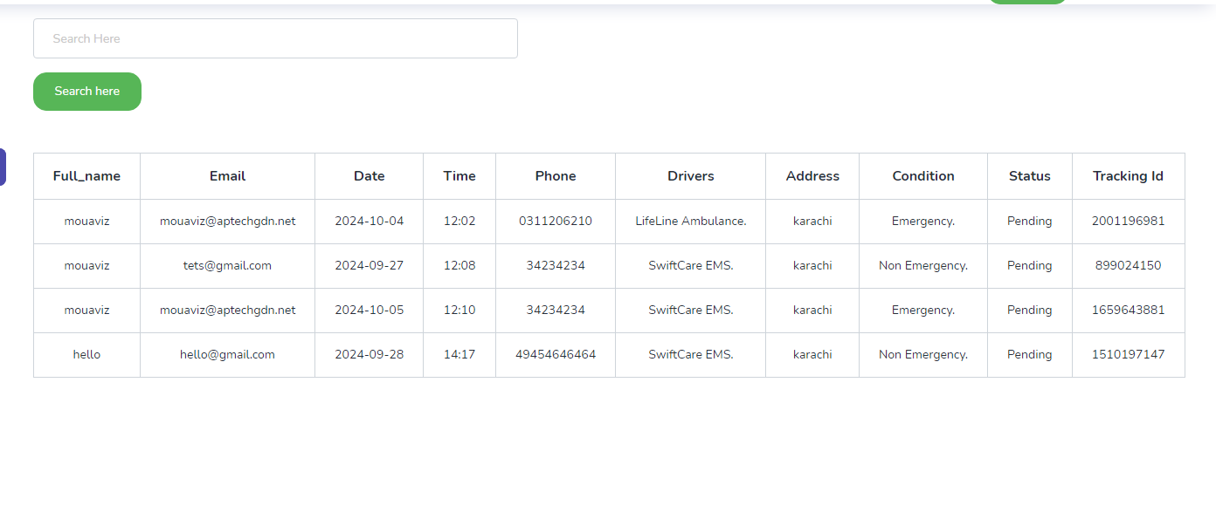

Ambulance data

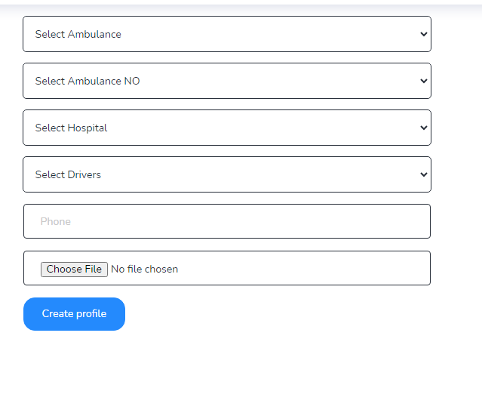

View ambulance

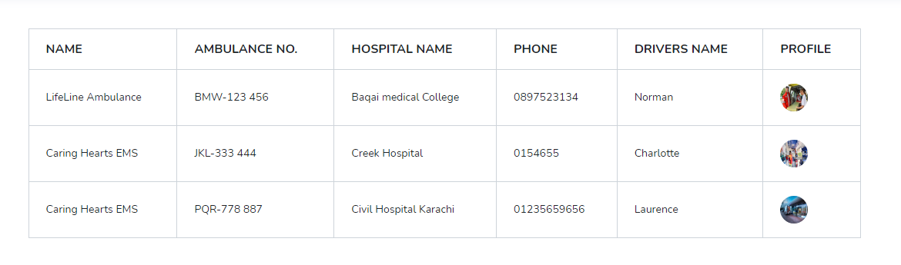

Add blog:

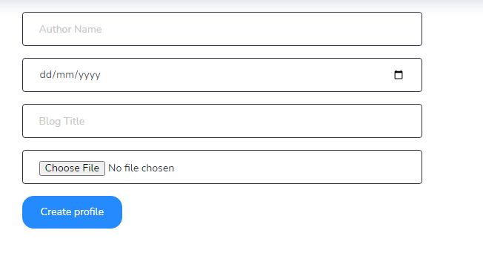

View blog:

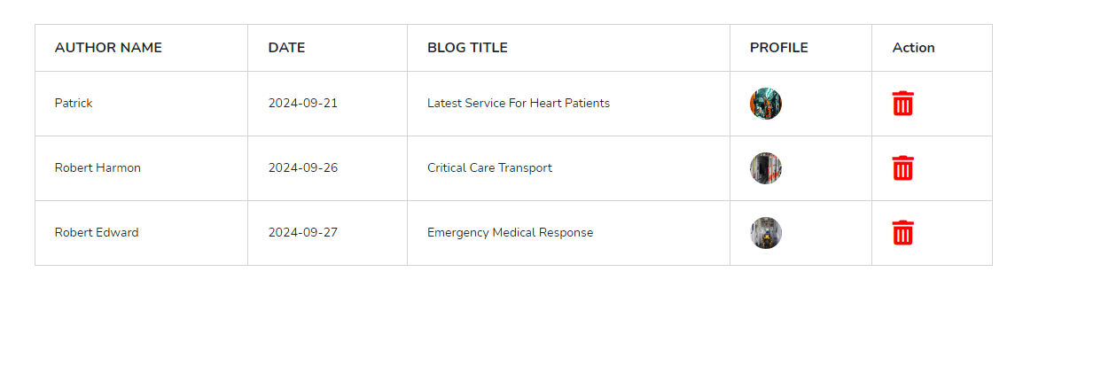

**USER DASHBOARD**

Insert Feedback:

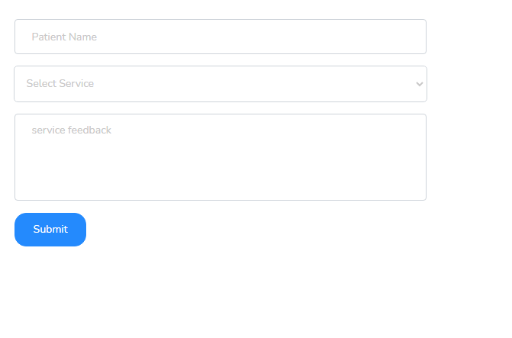

Show feedback:

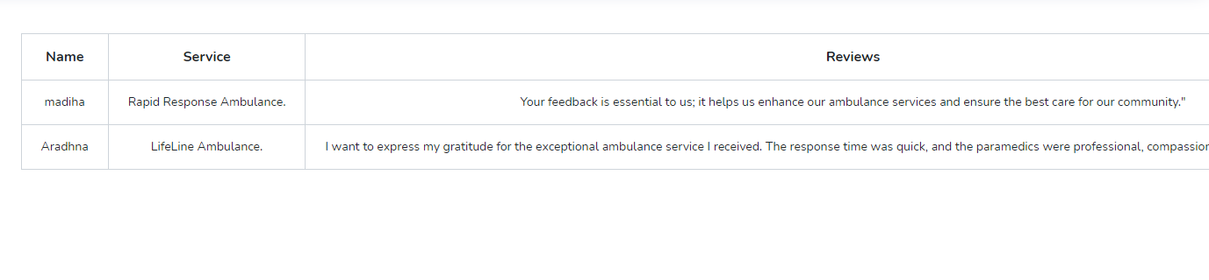

Contact record:

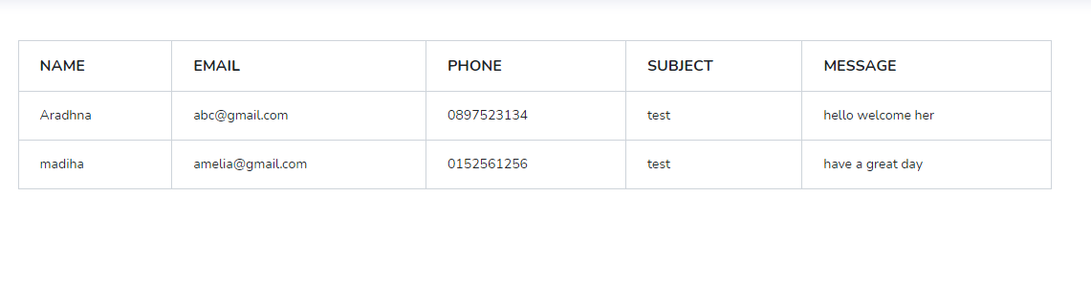

Show ambulance:

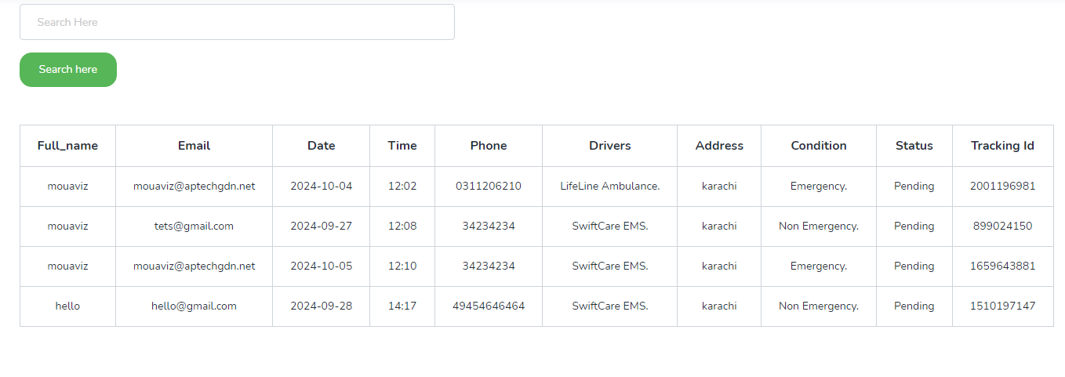

**scope of website:**

**E AMBULANCE SERVICE**

*1- Our latest drivers with latest ambulance also our latest and best services.*

**TESTIMONIAL**

*1- Patient will be able to look up their own feedback after submitting the survey of getting chance to avail our best services.*

**DRIVERS**

*1- Patients will be aware about the info regarding our hard working drivers.*

*2- Patients can be able to look up for driver’s contact number.*

**ABOUT US**

*1- Info regarding our professional staff and their ethics.*

*2- Success of our work hard.*

**CONTACT**

*1- Patient will be able to reach out to us through filling the contact form.*

*2- Patient must have to put their email and name and their personal information.*

**HOME**

*1- Registration and login.*

*2- Introduction & information related to our latest ambulance.*

**sitemap regarding dashboard**:

Insert and fetch Driver’s record

Driver’s Dashboard

Show Fedback

Contact Data

Driver Data

User’s Dashboard

Show Booking and search ambulance data

Show Contact

Show Feedback

Admin Dashboard

Show Services

Book Ambulance record (fetch and update)

Show & Delete record of Contact

Can see Patient’s feedback